1. Wired Connection

2. Configure Wi-Fi Without Logon to Desktop

[Ares 3D Printer](https://www.indiegogo.com/projects/ares-an-affordable-all-in-one-3d-printer) uses a Web based interface, [OctoPrint](http://octoprint.org/). So it doesn't care which operating system you use. However, some Mac users find instructions about establishing connection in the [User Manual](http://www.easyarts3d.com/forum/viewtopic.php?f=19&t=150) and [Simplified User Guide](http://www.easyarts3d.com/forum/viewtopic.php?f=19&t=2) hard to follow because examples are illustrated with Windows screenshots. So, here are a few notes to relax your nerves.

First of all, I'd like to point out that the Simplified User Manual contains much better and complete information about setting up connections than the User Manual. If you ignore disclaimers about Mac and Linux and just follow instructions therein, you'd be connected in no time. This said, Mac users could use some shortcuts and screenshots.

## 1. Wired Connection

by [**valleyman**](http://www.easyarts3d.com/forum/memberlist.php?mode=viewprofile&u=256) » 2016-01-30 22:49

Because [OctoPi](https://github.com/guysoft/OctoPi) (the underlying operating system in Ares) runs Bonjour by default, Mac users should be able to simply find a new machine named **octopi** on their Mac. In Terminal, try

ping octopi

You should see echoes from Ares' IP address, although thanks to Bonjour, you don't have to memorise the numbers.

In your browser, enter "octopi/" and you'll see OctoPrint's home page matching the screenshot in User Manual. (The trailing slash without "http" or "https" is a shortcut in modern address bar-doubled-as-search-window to signify that it is a Web page, not a string search.)

Similarly, if you need to connect to OctoPi's desktop (which is unrelated to the Web interface that the printer uses), use an [RDP](https://en.wikipedia.org/wiki/Remote_Desktop_Protocol) client such as [Microsoft Remote Desktop](https://itunes.apple.com/us/app/microsoft-remote-desktop/id715768417) (formerly known as Windows Remote Desktop), simply set your server name as octopi.

You can also use the name "octopi" (or OctoPi or any capitalisation variant), for ssh, scp, sftp, and so on. You can even find a network server called "octopi" in Finder. (More on this below.)

Note:

1. Bonjour sometimes fails. As such, you may want to use your DHCP server's features to fix Ares to the same IP address every time. (Most home network routers includes a DHCP server.) The User Manual suggests changing Ares' lease term to "Permanent"; [my other tip](http://www.easyarts3d.com/forum/viewtopic.php?f=22&t=453) suggests a feature called "Manual Assign" (which uses "preferred" feature in DHCP). Find out which feature your DHCP device supports.
2. Some users report that they have to use "octopi.local" instead of "octopi" on command line and browser. Despite some limitations, octopi.local appears to be more reliable.
3. The original VNC uses its own protocol that is incompatible with RDP. I haven't used VNC for a long time, so I cannot say whether modern VNC has RDP support.

## 2. Configure Wi-Fi Without Logon to Desktop

by [**valleyman**](http://www.easyarts3d.com/forum/memberlist.php?mode=viewprofile&u=256) » 2016-01-30 23:07

I used Microsoft Remote Desktop to log onto OctoPi's desktop in order to configure Wi-Fi. The procedure is exactly as described in the manuals. However, the Simplified User Guide describes a method to configure Wi-Fi without using desktop (or even ssh). Instead, the method uses SMB file sharing. Although SMB is supported in all modern OS’, the described procedure (referenced in the document as "Method 1 of step 2 in method 3") is Windows specific. Here is the Mac equivalent.

1. Go to Finder and open the "octopi" server. You are likely to see “Connection Failed” the first time.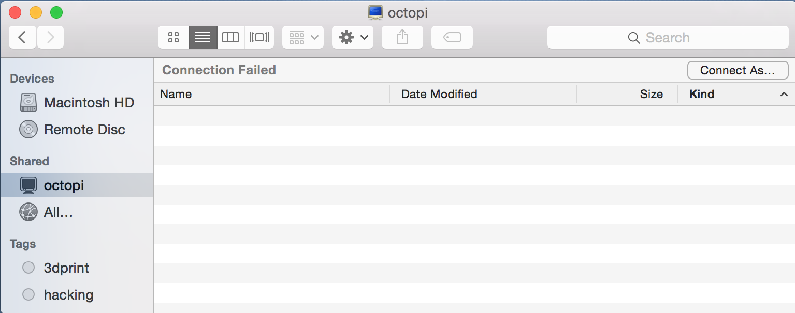
2. Click "Connect as". Now a popup window will ask you username and password. Username should be "pi", and default password is "raspberry".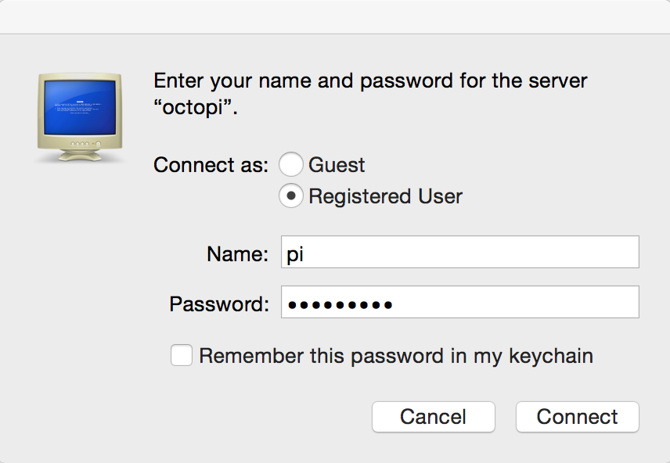
3. Once you are in, you'll see a folder "Ares". In it you'll see a file named wifi.conf. (The other file in the screenshot is generated only after a connection is established.)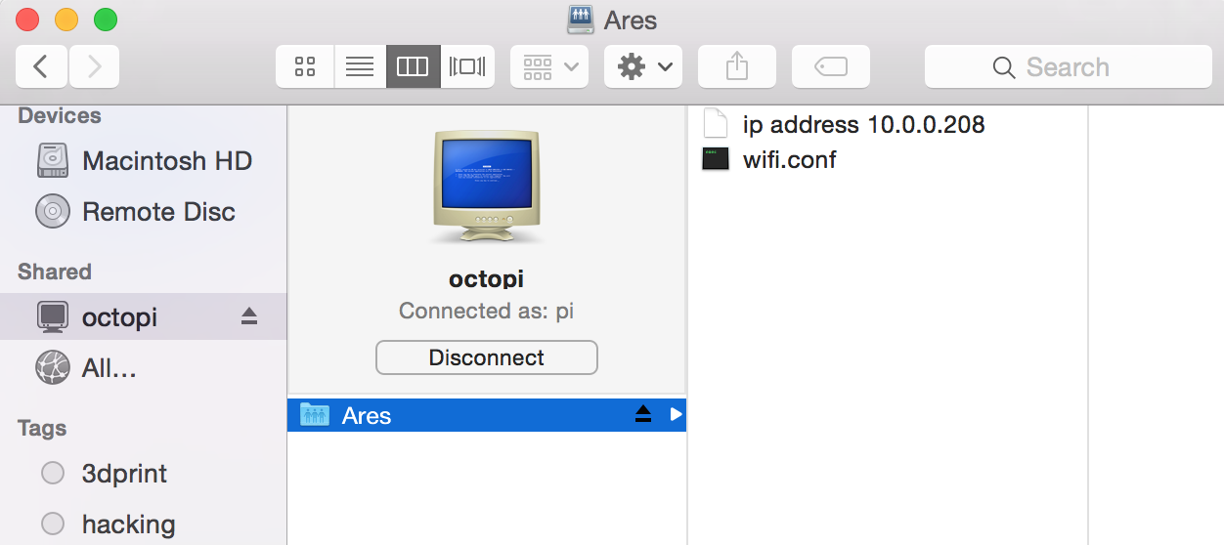
4. Open it with TextEditor or any editor you prefer. (Make sure to edit in plain text if your editor also supports rich text.) Alternatively, if you are a vi person, you can use it, too.

vi /Volumes/Ares/wifi.conf

1. The default content of the file is

ctrl_interface=DIR=/var/run/wpa_supplicant GROUP=netdev

update_config=1

network={

ssid="EasyArts"

psk="easyarts2014"

proto=WPA

key_mgmt=WPA-PSK

pairwise=CCMP

auth_alg=OPEN

}

Replace with your own SSID (Wi-Fi network name) and PSK (in some devices called password). Both these need to be quoted. Change PROTO to *RSN*. (No quotation mark.) Save, and your Wi-Fi connection should be up in a minute.